23.Write a Python program to draw a line using given axis values taken from a text file,
with suitable label in the x axis, y axis and a title.
Aim:
To write a Python program to draw a line using axis values taken from a text file with suitable X-axis, Y-axis labels and title.

Code:
import matplotlib.pyplot as plt
x = []
y = []
with open("data.txt") as f:
for line in f:
a, b = line.split()
x.append(int(a))
y.append(int(b))
plt.plot(x, y)
plt.xlabel("X Values")
plt.ylabel("Y Values")
plt.title("Line Plot from Text File")
plt.show()

Output:
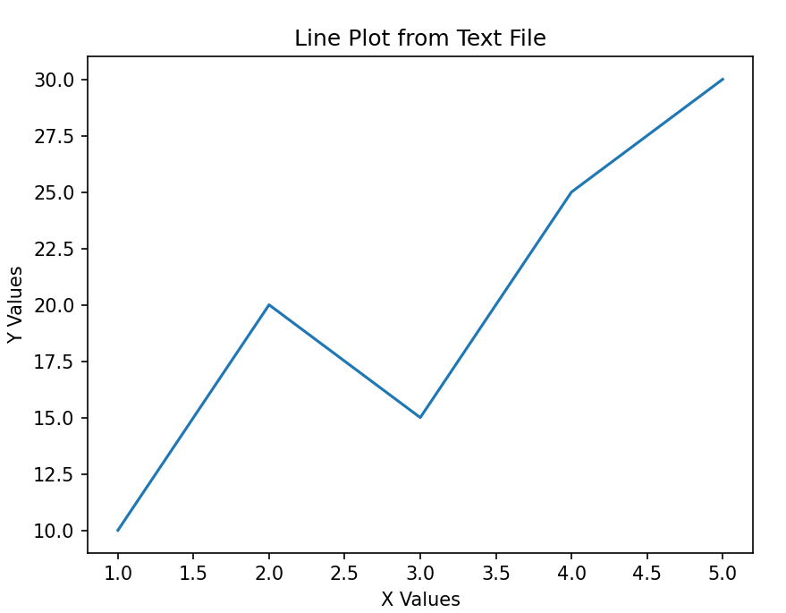
Result:
The line graph was successfully drawn using the values from the text file.

24.Write a Python program to draw line charts of the financial data
Aim:
To write a Python program to draw a line chart representing financial data for different years.

Code:
import matplotlib.pyplot as plt
year = [2019,2020,2021,2022,2023]
income = [45000,50000,52000,61000,70000]
plt.plot(year, income, marker="o")
plt.xlabel("Year")
plt.ylabel("Income")
plt.title("Financial Data")
plt.grid()
plt.show()
Output:
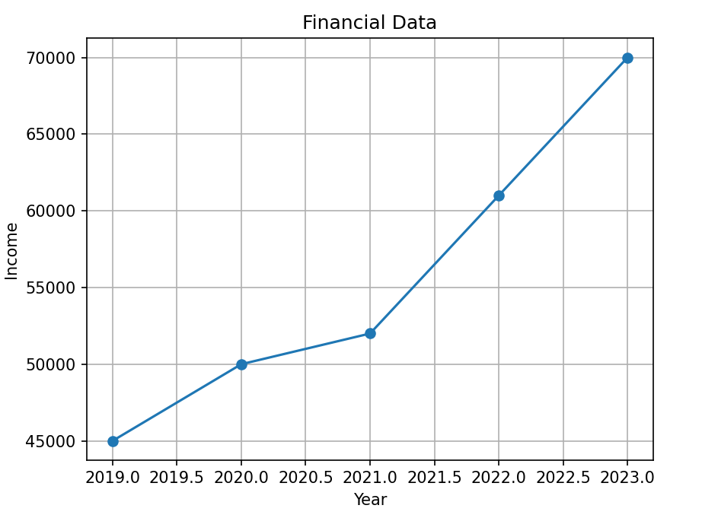

Result:
The financial data line chart was successfully drawn showing the income for different years.

